**MINI PROJECT REPORT**

**TEAM :**

**PRANAV KORE 2021300065**

**ANAND KRISHNA 2021300066**

**TITLE :**

**2048 GAME**

**PROBLEM DEFINITION :**

* WE ARE HERE TRYING TO BUILD 2048 PUZZLE GAME , WHERE WE TRY TO ACHIEVE 2048 NUMBER IN ORDER TO WIN IT .
* 2048 is single player game which is played on 4*4 board which has total of sixteen tiles .
* you join the numbers and get to 2048 tile .

**SCOPE:**

* The project aims to simulates the board gamE 2048.
* WE JUST RANDOMLY SEARCHED ABOUT BOARD GAMES AND OF ALL OF THEM ,WE FOUND 2048 WAS MOST EXICITING ONE .
* IT IS A SIMPLE BOARD GAME ,TYPICALLY A SINGLE PLAYER GAME . WE MADE THIS GAME IN ORDER TO DEVELOP COORDINATION AND INCREASE OUR ABILITY SYSTEMATICALLY .
* THIS GAME IS USER FRIENDLY I.E WE HAVE CREated an option of undo , restart. also sound effects have been added to make game look more appealing .

**OBJECTIVES:**

* TO CREATE THE USER FRIENDLY GAME ALSO SHOULD BE EASY TO USE.
* THE WEBSITE SHOULD USE STACK DATA STRUCTURE TO IMPLEMENT THE GAME.
* **T**HE GAME SHOULD HAVE ALL BASIC FUNCTIONALITY LIKE UNDO, RESTART, DISPLAY OF SCORE AND NO. OF MOVES .
* **DATA STRUCTURES AND ITS USAGE :**
* WE HAVE USED STACK DATA STRUCTURE TO IMPLEMENT THE GAME.
* its a linear data structure which follows a particular order in which operations are performed .
* IT USES STACK DATA STRUCTURE IN ADDING NUMBERS ZerO'S (pUSH oPERATION) IN A ROW AND COLUMNS AND ALSO TO RANDOMLY ADDING 2 OR 4 IN THE RANDOM TILE.

1. THE BELOW PUSH OPERATION IS ADDING ZEROS IN BLANK SPACES IN THE ROW OR COLUMN AS PER THE SHIFT USING STACK DATA STRUCTURE .

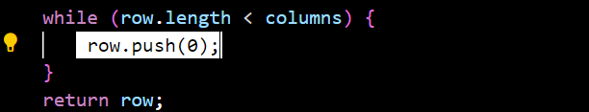

2.THE BELOW PUSH OPERATION IS DIFFERENT FROM ABOVE ONE. THIS PUSH IS ADDING 2 OR 4 RANDOMLY IN THE ARRAY WHICH IS MADE OF BLANK SPACES IN THE BOARD.

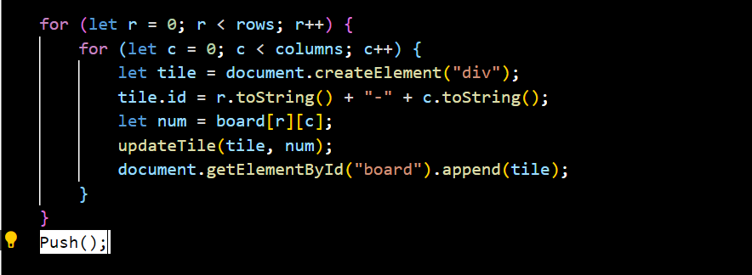

**PROJECT PLAN AND TIMELINE :**

* AT FIRST WE STARTED KNOWING ABOUT REQUIREMENTS OF OUR PROJECT LIKE WHAT ALL IS NEEDED TO MAKE 2048 GAME .
* WE GOT TO KNOW WE NEED TO LEARN HTML,CSS AND JAVASCRIPT FOR IT . BOTH OF US HAVE LEARNT THAT.
* WE HAVE USED HTML FOR DESCRIBING THE STRUCTURE OF WEB PAGE LIKE SCORE ,NEW GAME BUTTON HAVE BEEN ADDED USING IT . the layout has been made using it .
* FOR DESIGNING PURPOSE WE HAVE USED CSS I.E COLOURS HAVE BEEN ADDED TO TILES ALSO AT VARIOUS OTHER PLACES AND LAYOUT HAS BEEN MADE TO LOOK MORE ATTRACTIVE .
* LATER ON FOR INTERACTIVE BEHAVIOUR WE HAVE USED JAVASCRIPT WHERE IN THE MAIN PURPOSE OF PROJECT , USING THE DATA STRUCTURE STACK WE HAVE CREATED THE PROJECT .
* ALL THE FUNCTIONS OF GAME LIKE SLIDING TO LEFT, RIGHT UP AND DOWN EVERYTHING HAS BEEN MADE USING JAVASCRIPT .
* FURTHER WE HAVE ALSO ADDED SOUND EFFECTS IN THE GAME I.E WHEN THE TILES COMBINE WE GET THOSE SOUNDS . AFTER ALL MAIN PURPOSE WAS TO make IT USER FRIENDLY .
* AT THE END we have made some minor changes like no. of moves , bACKTRACKING and all are added .

**IMPLEMENTATION DETAILS :**

1. HTML – FOR LAYOUT

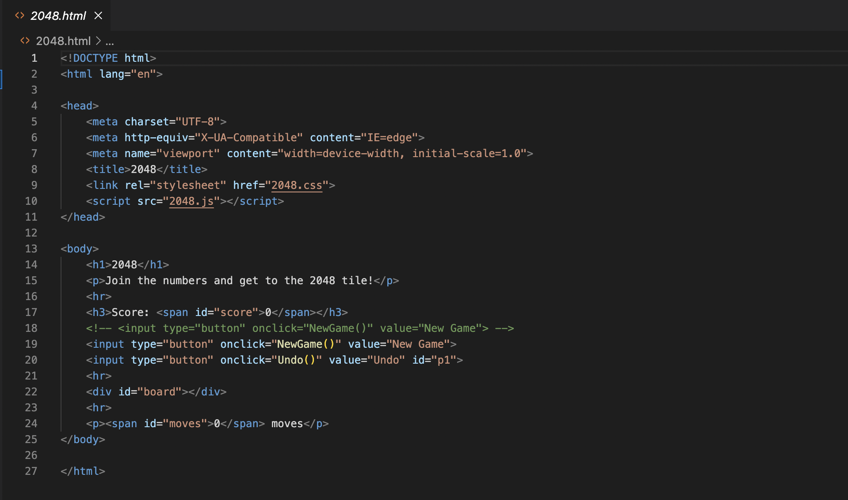

1. CSS – FOR DESIGN

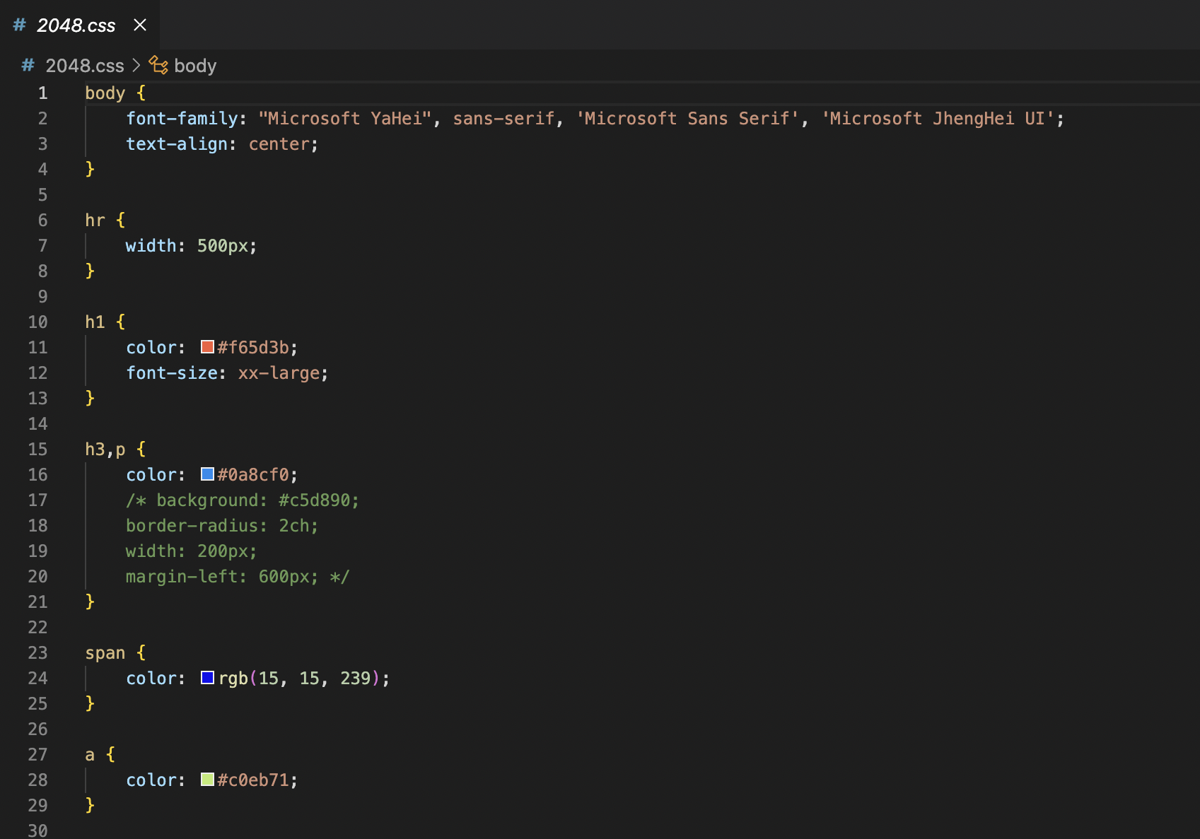

1. JAVASCRIPT – FOR INTERACTIVE BEHAVIOUR

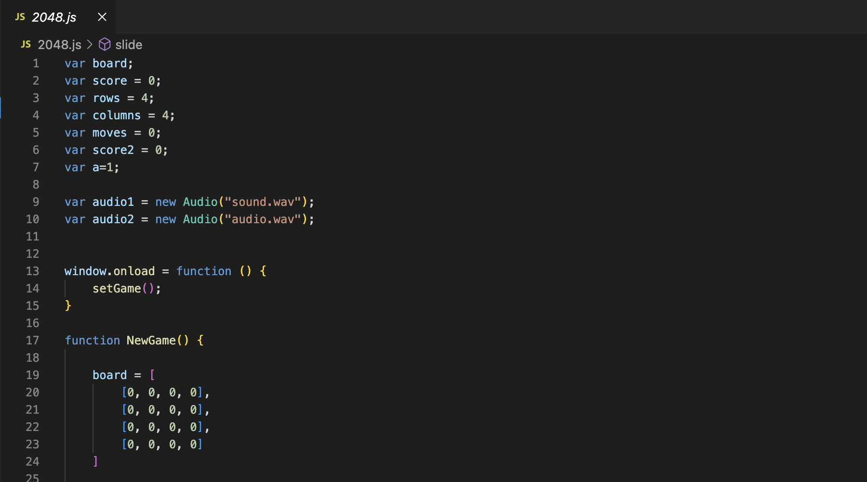

**CONCLUSION:**

FROM THIS PROJECT WE HAVE LEARNT HOW TO USE HTML,CSS AND JAVASCRIPT FOR MAKING WEBSITES . ALSO The project has immensely enhanced our understanding of data structures and algorithms.